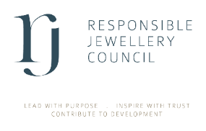
Commercial Member

New Entity Declaration Form

Name of member company

DETAILS OF NEW ENTITY

Name of entity | City, Country | Business activity | No. of Employees | RJC materials

DIRECTORS & SHAREHOLDERS
Please enter the full name for all Directors and all shareholders that own 20% or above of the new entities.

Directors (Full Name) | Shareholders (Full Name)

Submit to membership@responsiblejewellery.com with all required documents outlined in our checklist.

4. Declaration
I declare that to the best of my knowledge and belief the information provided is complete, accurate and up to date.
I confirm that I have provided all the required documents as outlined in RJC’s checklist.
Signed: Name: Date:

Position: Date:

