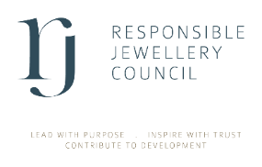
Commercial Member

New Facility Declaration Form

A facility is not a legal entity with its own business registration number. A facility is a premise in RJC scope at a separate address. For example, facilities could be retail stores, trading offices, manufacturing sites, and warehouses.

Name of member company

DETAILS OF NEW FACILITIES

Name of facility | City, Country | Business activity | No. of Employees | RJC materials

Submit this form to membership@responsiblejewellery.com and inform your audit firm.

4. Declaration
I declare that to the best of my knowledge and belief the information provided is complete, accurate and up to date.
I confirm that I have provided all the required documents as outlined in RJC’s checklist.
Signed: Name: Date:

Position: Date:

